

**HOSPITAL MANAGEMENT SYSTEM**

**Submitting To:**

**Miss Rimsha**

**BY:**

**Group Member 01: Sadia (SP22-BSSE-0067)**

**Group Member 02: Fizza Khan (SP220053)**

**Table Of Contents**

**INTRODUCTION ....................................................... 3 Problem Statement ……………………………….**

**SOLUTION ……………………………………………… Features ………………………………………………….. SOURCE CODE ........................................................... 5 ALGORITHM .............................................................. 5 RESULTS ..................................................................... 6 Conclusions …………………**

**INTRODUCTION**

The project of the Hospital management system includes the registration of patients, patient records, and Doctor details stored store in the system. The system of hospital management also includes the computerized billing system that is into the computer. The software can give the unique detail of every patient, doctor, and, staff member Automatic users can search for the user availability of a doctor. This system provides the ability to manage all the paperwork in one place, reducing the work of staff in arranging and analyzing the paperwork of the patient. This time-saving technology improved efficiency by avoiding human errors. there are more chances of data security and correct data retrieval made possible. There is an easy way to access the patient data with correct patient history.

It easily maintains the records of the patient.

Maintain the contact details of patients.

Tracking the bill payments.

Reduces the work of documentation

Easy monitoring of supplies in inventory.

**Problem Statement:**

Nowadays putting information in paperwork is very lengthy and tedious work. Various changes to information like patient details or information details of a child are difficult to make as paperwork involves.

**Solution:**

This management system helps us to maintain the patient details by providing

Computerized billing system and report generation. It can also be used in many hospitals, clinics, and labs for maintaining patient details. So, the whole

Paperwork that was written manually is converted into the database management system to easily retrieve the data of patient, and doctor details too.

**Features:**

It includes some basic hospital information system modules. Patient management is used to control the patient flow. It can be used to register them, get the data on the patient's health condition, view treatment, and check the medical history and reports.

* Doctor management system
* Patient management system
* Takes appointments easily
* Doctor scheduling system
* Provides a prescription checking previous case study
* Account management system

**SOURCE CODE**

#include<iostream>

#include<fstream>

#include<string.h>

#include<conio.h>

#include<unistd.h>

#include<windows.h>

using namespace std;

void details(){

cout<<"Hospital details"<<endl;

cout<<"Hospital is a place where the sick and the injured are taken for treatment."<<endl;

cout<<"The doctors and nurses are readily available there for admitting and attending."<<endl;

cout<<"on their patients.The dedicated team of doctors and nurses delivers the message"<<endl;

cout<<"of hope to their patients in the hospitals.All over the world,hospitals are built"<<endl;

cout<<"to treat and cure thousands of the sick patients.As these hospitals,there are very"<<endl;

cout<<"well-equipped facilities and expert doctors.These hospitals are considered the best"<<endl;

cout<<"place for effective treatment.The doctor and nurses do their work with a dedication"<<endl;

cout<<"and maintain the pleasant atmosphere of the hospitals so that the patient feel comfortable and better"<<endl;

cout<<endl;

}

void app(){

ofstream MyFile("PatientDetails.txt",ios::in|ios::out|ios::app);

string fname, lname, pprob,padd;

int page,ppay,ch,doc ;

double pnum, pay;

cout<<endl;

//patient appoint

cout<<"Patient Appointment"<<endl;

cout<<"Enter your credentials"<<endl;

cout<<"Enter your first name:"<<endl;

cin>>fname;

cout<<"Enter your last name:"<<endl;

cin>>lname;

cout<<"Enter your number:"<<endl;

cin>>pnum;

cout<<"Enter your age:"<<endl;

cin>>page;

cout<<"Enter the problem for which you want the consultation(1/2/3/4)"<<endl;

cout<<" 1.Dr.Maryam Khan/ Gynaecologist"<<endl;

cout<<" 2.Dr.Abdulllah/ Eye specialist"<<endl;

cout<<" 3.Dr.Tariq/ Heart specialist"<<endl;

cout<<" 4.Dr.Uzma/ Kidney specialist"<<endl;

cout<<" 5.Dr.Ali/Neurologist specialist"<<endl;

cin>>doc;

if(doc==1){

cout<<"Your appointment is confirmed with Dr.Maryam"<<endl;}

else if(doc==2){

cout<<"Your appointment is confirmed with Dr.Abdullah"<<endl;}

else if(doc==3){

cout<<"Your appointment is confirmed with Dr.Tariq"<<endl;}

else if(doc==4){

cout<<"Your appointment is confirmed with Dr.Uzma"<<endl;}

else if(doc==5){

cout<<"Your appointment is confirmed with Dr.Ali"<<endl;}

else{

cout<<"Invalid Input"<<endl;

}

// Write to the file

MyFile <<"Patient Name :"<< fname << lname << "," << "Mobile Number : " << pnum << "," << "Age : " <<page << "," << "Assigned Doctor : " << doc <<endl;

// Close the file

}

int main(){

ofstream MyFile("PatientDetails.txt",ios::in|ios::out|ios::app);

string fname, lname, pprob,padd;

int page,ppay,ch,doc ;

double pnum, pay;

cout<<"\n\n\n\n\n\n\n\n\n\n\n\n\n\n\n\n\n\n\t\t\t\t\t@@@@@@@@@@@@@@@@@@@@@@@@@@@@@@@@@@@@@@@@@@@@@@@@@@@@@@@@@@@@@@@@@@@@@@@@@@@@@@@@@@@@@@@@@@@@@\n";

cout<<"\t\t\t\t\t@@ ___________ @@\n";

cout<<"\t\t\t\t\t@@| |@@\n";

cout<<"\t\t\t\t\t@@| |@@\n";

cout<<"\t\t\t\t\t@@| |@@\n";

cout<<"\t\t\t\t\t@@| |@@\n";

cout<<"\t\t\t\t\t@@| |@@\n";

cout<<"\t\t\t\t\t@@| |@@\n";

cout<<"\t\t\t\t\t@@| WELCOME TO |@@\n";

cout<<"\t\t\t\t\t@@| |@@\n";

cout<<"\t\t\t\t\t@@| HOSPITAL MANAGEMENT SYSTEM |@@\n";

cout<<"\t\t\t\t\t@@| |@@\n";

cout<<"\t\t\t\t\t@@| |@@\n";

cout<<"\t\t\t\t\t@@| |@@\n";

cout<<"\t\t\t\t\t@@| |@@\n";

cout<<"\t\t\t\t\t@@| |@@\n";

cout<<"\t\t\t\t\t@@| |@@\n";

cout<<"\t\t\t\t\t@@|___________|@@\n";

cout<<"\t\t\t\t\t@@@@@@@@@@@@@@@@@@@@@@@@@@@@@@@@@@@@@@@@@@@@@@@@@@@@@@@@@@@@@@@@@@@@@@@@@@@@@@@@@@@@@@@@@@@@@\n\n\n\n\t\t\t\t\t";

system("pause");

do {

cout<<"Enter from one of the choices given"<<endl;

cout<<"1.Hospital Details"<<endl;

cout<<"2.Patient appointment"<<endl;

cout<<"3.Treament Payment"<<endl;

cout<<"4. Exit"<<endl;

cin>>ch;

system("cls");

if(ch==1){//hospital Details

details();

}

else if(ch==2){//start

app();

}//end

else if(ch==3){//treatment//main

cout<<"Enter the number for the doctor you want to make payment"<<endl;

cout<<" 1.Dr.Maryam Khan/Gynaecologist"<<endl;

cout<<" 2.Dr.Abdulllah/ Eye specialist"<<endl;

cout<<" 3.Dr.Tariq / Heart specialist"<<endl;

cout<<" 4.Dr.Uzma / Kidney specialist"<<endl;

cout<<" 5.Dr.Ali / Neurologist"<<endl;

cin>>pay;

if(pay==1){

do{

cout<<" Amount is 2000 rupees "<<endl;

cout<<"Enter payment"<<endl;

cin>>ppay;

if(ppay<2000){

cout<<"Payment should be greater or equal than the amount"<<endl;

}

MyFile <<"Amount paid:" <<ppay <<endl;

}while(ppay!=2000);//end

}

else if(pay==2){

do{

cout<<" Amount is 3000 rupees "<<endl;

cout<<"Enter payment"<<endl;

cin>>ppay;

MyFile <<"Amount paid:" <<ppay <<endl;//i've put filing here after cin

//do this in every condition

if(ppay<3000){

cout<<"Payment should be greater or equal than the amount"<<endl;

}

}while(ppay!=3000);//end

}

else if(pay==3){

do{

//this would come before do while if(pay==3){

cout<<" Amount is 2500 rupees "<<endl;

cout<<"Enter payment"<<endl;

cin>>ppay;

if(ppay<2500){

cout<<"Payment should be greater or equal than the amount"<<endl;

}

MyFile <<"Amount paid:" <<ppay <<endl;

}

while(ppay!=2500);//end//this would go in the else if statement

}

else if(pay==4){

do{

cout<<" Amount is 1000 rupees "<<endl;

cout<<"Enter payment"<<endl;

cin>>ppay;//put filing here

if(ppay<1000){

cout<<"Payment should be greater or equal than the amount"<<endl;

}

MyFile <<"Amount paid:" <<ppay <<endl;//put this filing after cin

}

while(ppay!=1000);//end

}

else if(pay==5){

do{

cout<<" Amount is 1500 rupees "<<endl;

cout<<"Enter payment"<<endl;

cin>>ppay;

MyFile <<"Amount paid:" <<ppay <<endl;//i did it here

if(ppay<1500){

cout<<"Payment should be greater or equal than the amount"<<endl;

}

MyFile <<"Amount paid:" <<ppay <<endl;//put this filing after cin

}

while(ppay!=1500);//end

} //main

else if(ch==4){

cout<<"Exit"<<endl;

cout<<"Thank you for visiting our hospital"<<endl;

}

else{

cout<<"Invalid input";

}

}

}while(ch!=4);

system("cls");

cout<<"\n\n\n\n\n\n\n\n\n\n\n\n\t\t\t\t\t@@@@@@@@@@@@@@@@@@@@@@@@@@@@@@@@@@@@@@@@@@@@@@@@@@@@@@@@@@@@@@@@@@@@@@@@@@@@@@@@@@@@@@@@@@@@@\n";

cout<<"\t\t\t\t\t@@ ___________ @@\n";

cout<<"\t\t\t\t\t@@| |@@\n";

cout<<"\t\t\t\t\t@@| |@@\n";

cout<<"\t\t\t\t\t@@| |@@\n";

cout<<"\t\t\t\t\t@@| |@@\n";

cout<<"\t\t\t\t\t@@| |@@\n";

cout<<"\t\t\t\t\t@@| THANK YOU FOR USING |@@\n";

cout<<"\t\t\t\t\t@@| |@@\n";

cout<<"\t\t\t\t\t@@| HOSPITAL MANAGEMENT SYSTEM |@@\n";

cout<<"\t\t\t\t\t@@| |@@\n";

cout<<"\t\t\t\t\t@@| |@@\n";

cout<<"\t\t\t\t\t@@| |@@\n";

cout<<"\t\t\t\t\t@@| |@@\n";

cout<<"\t\t\t\t\t@@| |@@\n";

cout<<"\t\t\t\t\t@@| |@@\n";

cout<<"\t\t\t\t\t@@|___________|@@\n";

cout<<"\t\t\t\t\t@@@@@@@@@@@@@@@@@@@@@@@@@@@@@@@@@@@@@@@@@@@@@@@@@@@@@@@@@@@@@@@@@@@@@@@@@@@@@@@@@@@@@@@@@@@@@\n\n\n\n\t\t\t\t\t";

}

**Algorithm:**

Step 1:

The program starts with the home screen that contains a welcome page and portal that are presented on the home screen, and the program starts with the registration page.

Step 2:

Then check out the allocated memory for the next patient information.

Step 3:

Then enter the user information that is directly saved to the file name “patient details”, the file information is imputed through the conditional statements.

Step 4:

Create an entry to the database

Step 5:

Allocate the doctor for the patient according to the patient's disease.

Step 6:

Initiate the patient payment system.

Step:7

The end of the program takes place with thanking.

**RESULTS**

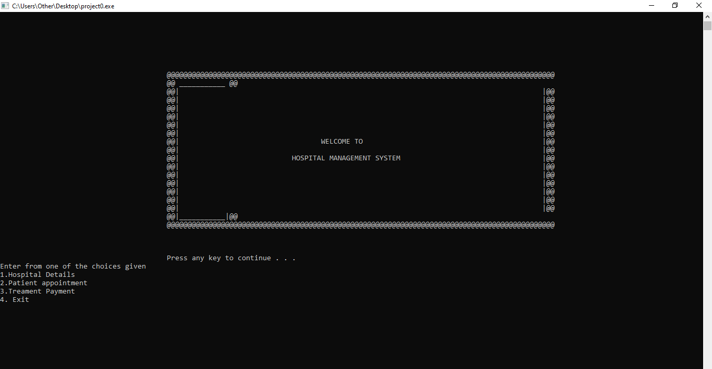

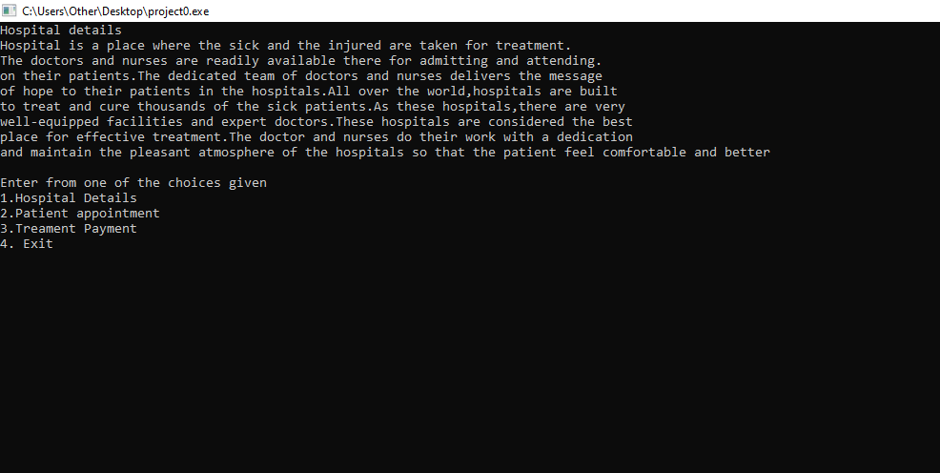

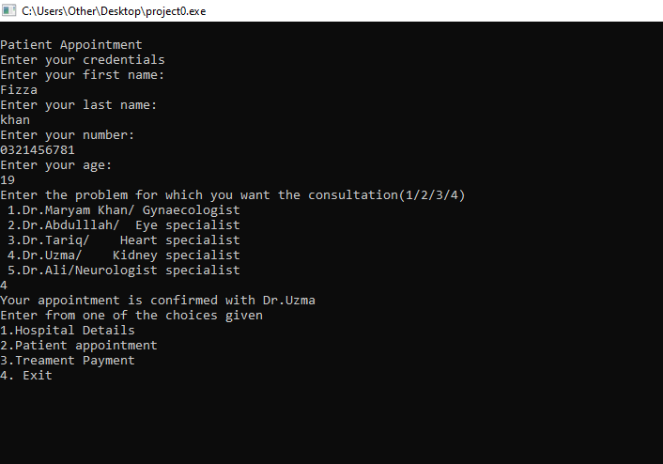

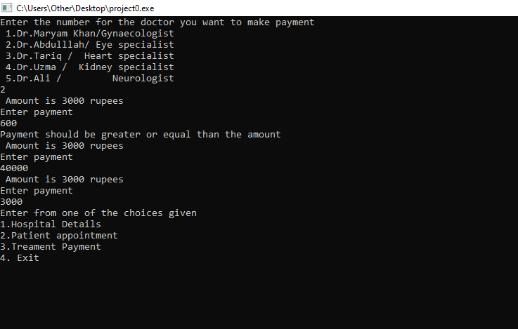

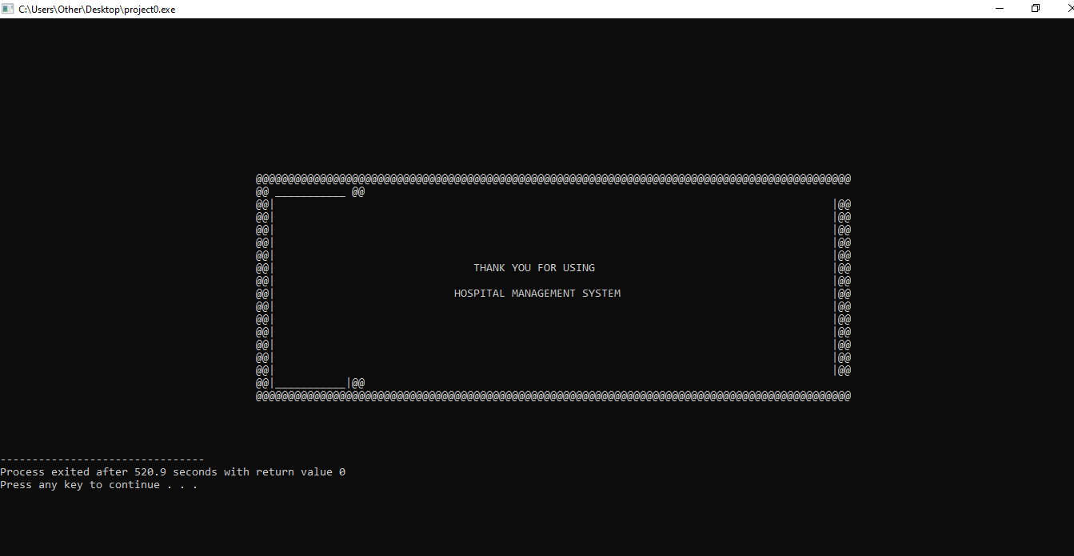

**Conclusion:**

The project Hospital Management System (HMS) is for computerizing the working in a hospital. The software takes care of all the requirements of an average hospital and is capable of providing easy and effective storage of information related to patients that come up to the hospital.

This system is all about modernizing a hospital through use of technology. Computers help in it and take over the manual system for quick and easy functioning. This hospital management system is quite reliable and is proven in many stages. All the basic requirements of the hospital are provided to manage it perfectly and a large amount of data can also be stored. It gives many facilities like searching for the details of patients, billing facilities as well as the creation of test reports. So it’s an important system for modern days***.***